**Tasks on Load Balancer**

**1) Configure Classic Load balancer.**

Launching two instances from different subnets as ELB requires minimum 2 subnets.  
Using bootstrapping/user data installing httpd and deploying index.html in both the instances.

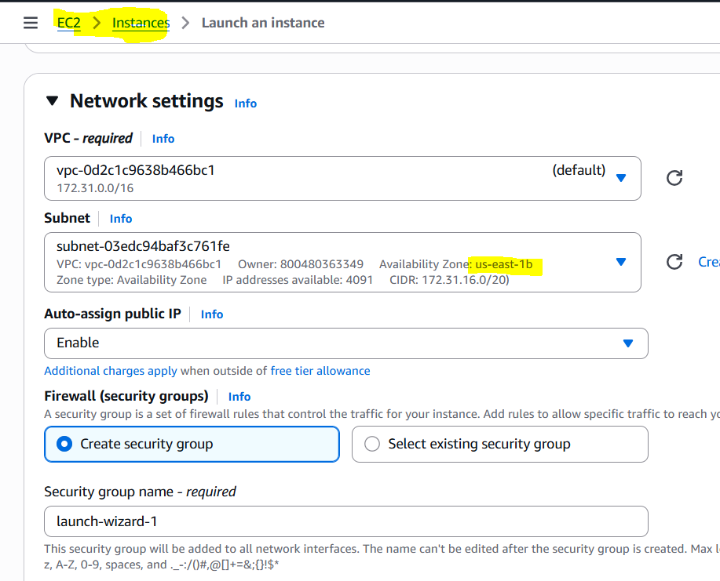

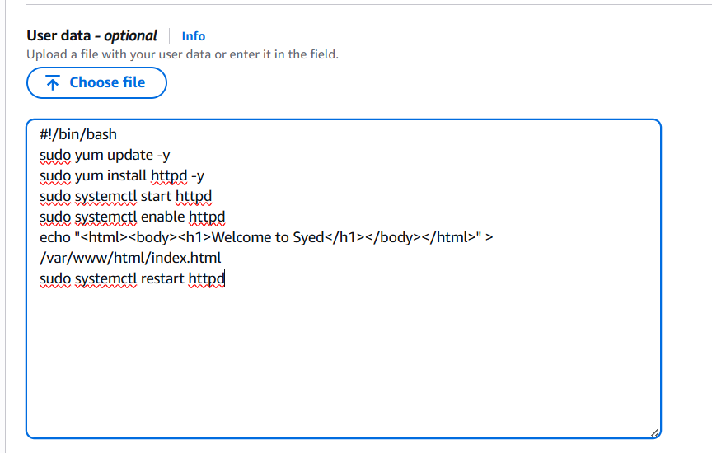

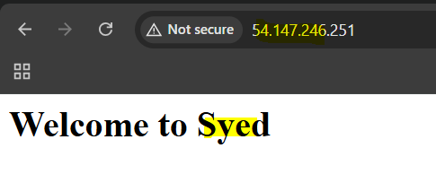

Similarly creating one more instance,  
  
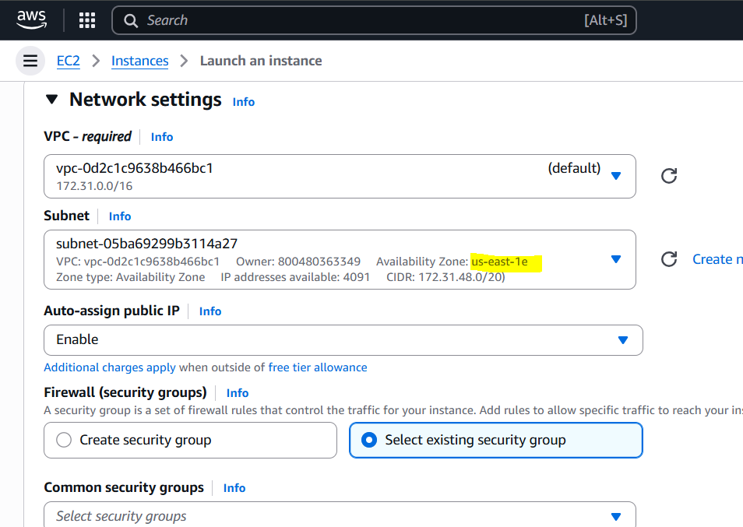

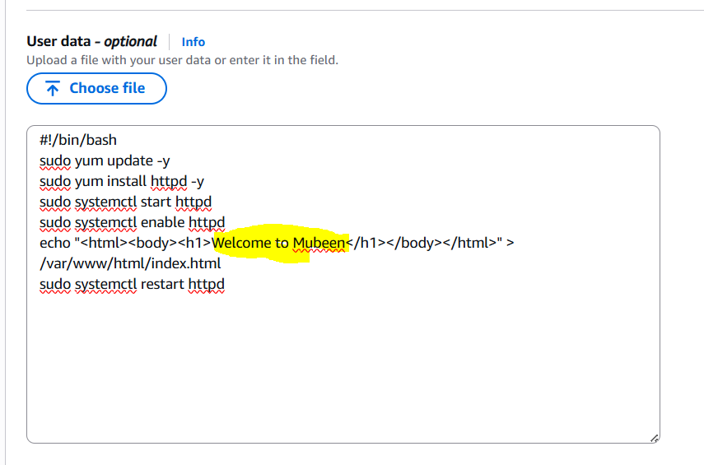

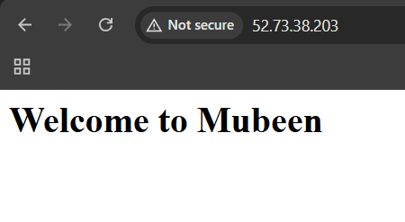

Creating CLB with these launched instances.

1. Create a CLB: Go to the EC2 dashboard and click on "Load Balancers" > "Create Load Balancer" > "Create Classic Load Balancer".

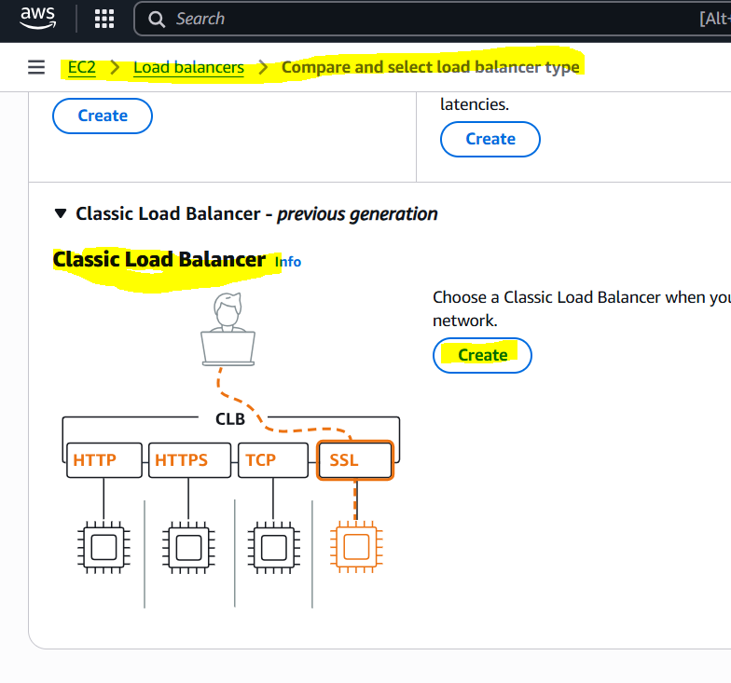

2. Configure CLB settings: Enter a name, select the VPC, and choose the Availability Zones.

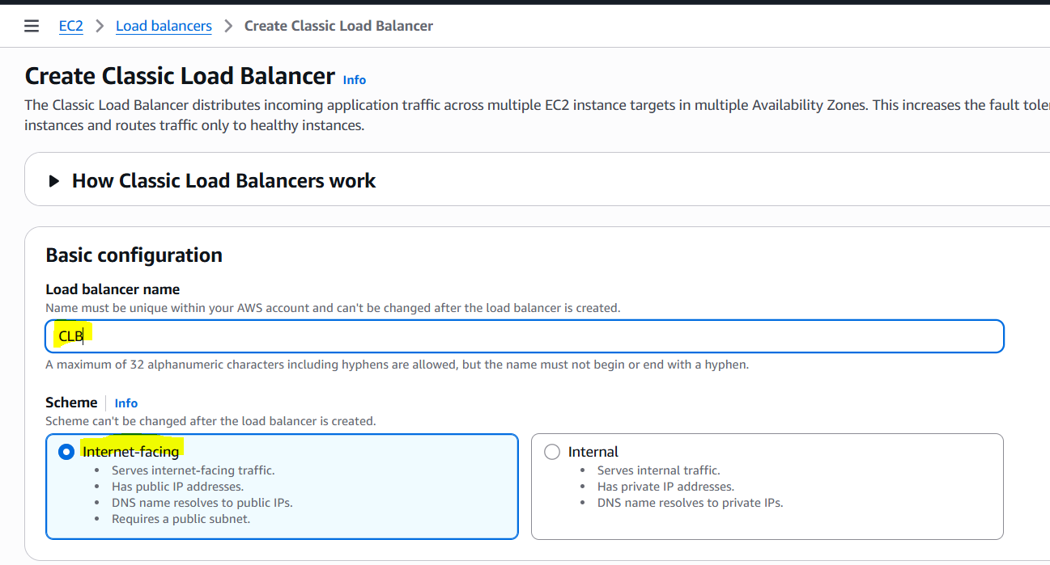

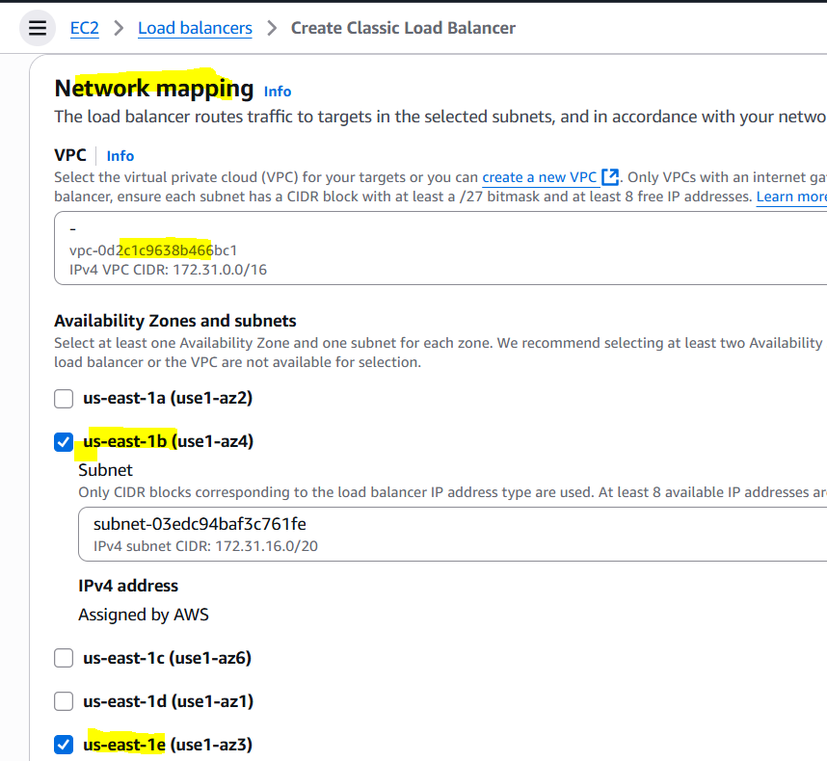

3. Configure security settings: Select the security groups.

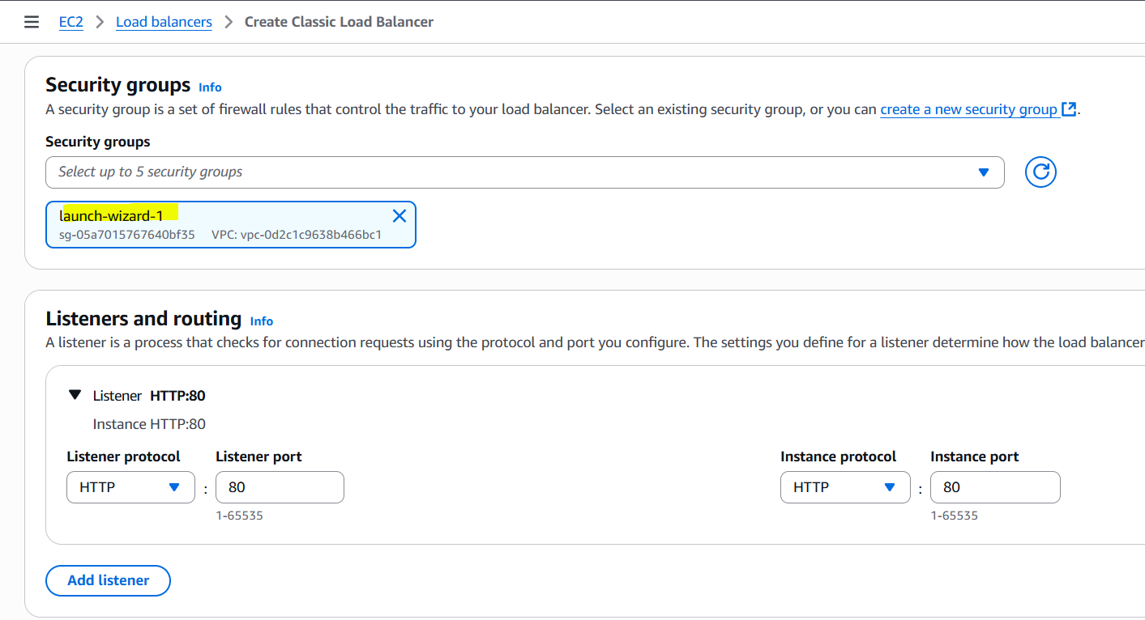

4. Configure health check: Set the ping protocol, ping port, and response timeout.

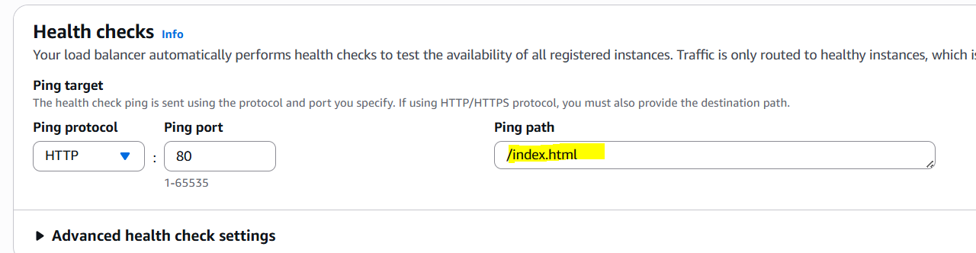

5. Add instances: Select the EC2 instances to add to the CLB.

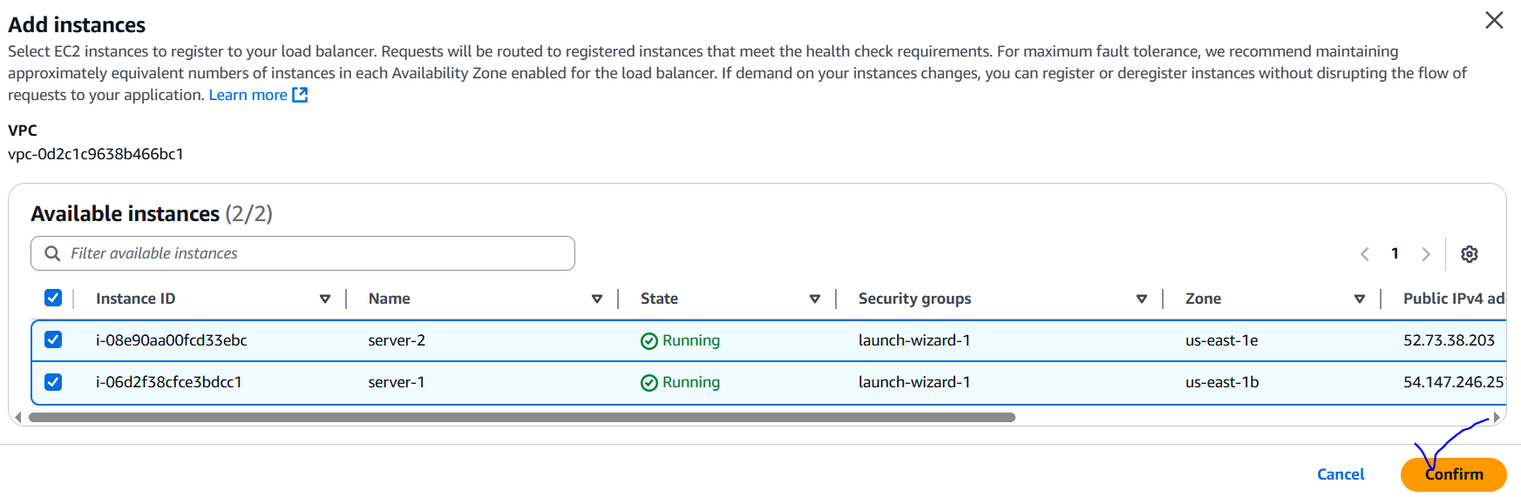

6. Configure listeners: Set the load balancer port and instance port.

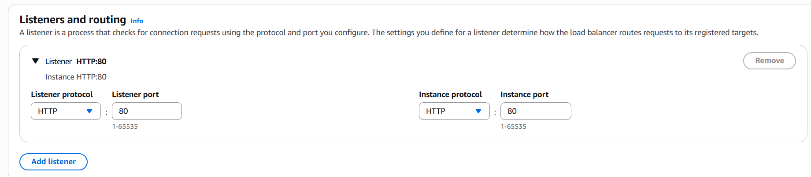

7. Review and create: Review the CLB settings and click "Create".

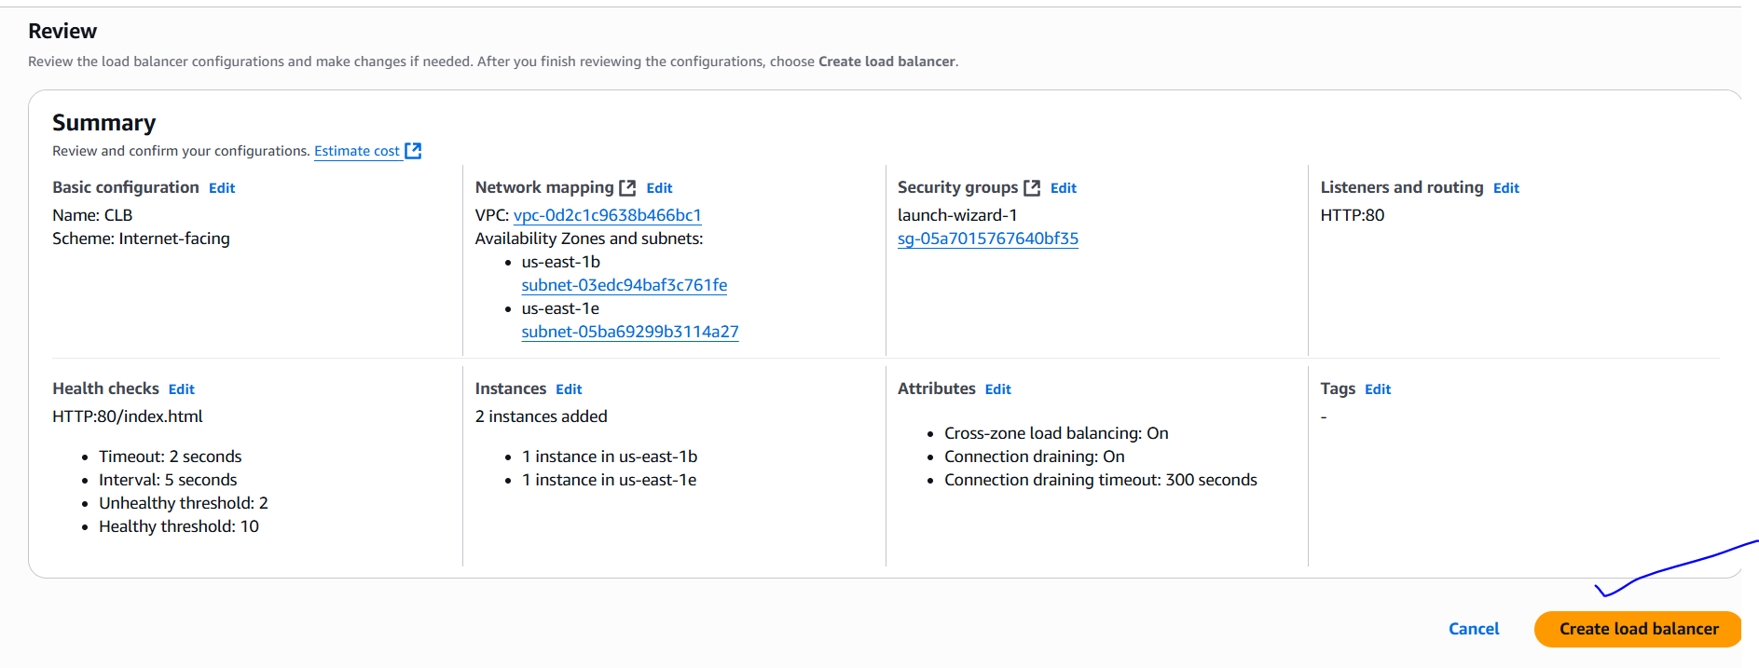

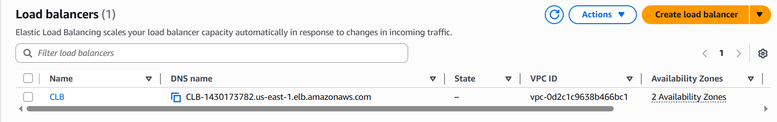

For testing copy DNS name and search in browser. For every refresh content must be changed as CLB follows round robin algorithm.

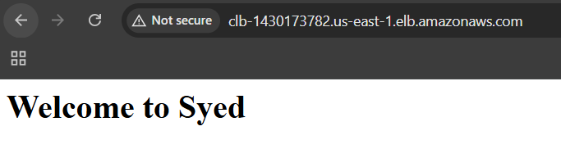

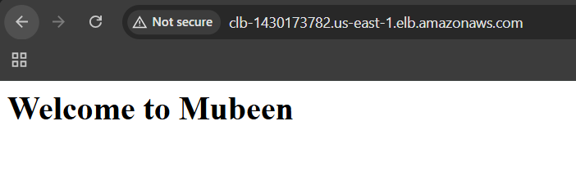

**2) Configure Application Load balancer.**Using the Existing 2 instances.

1. Create an ALB: Go to the EC2 dashboard and click on "Load Balancers" > "Create Load Balancer" > "Create Application Load Balancer".

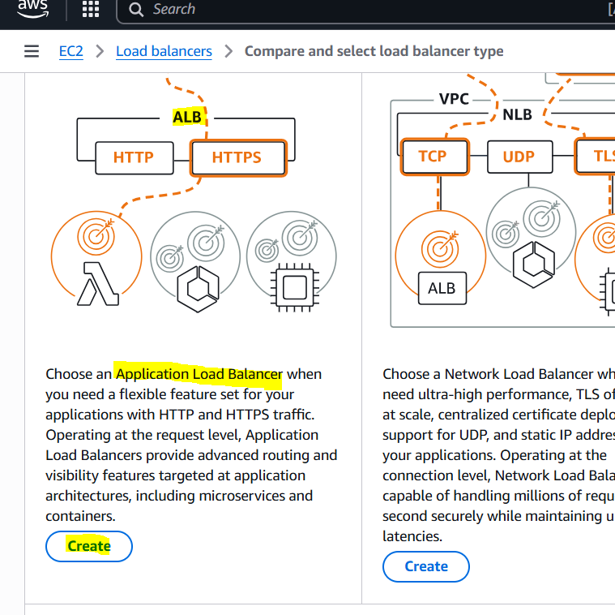

2. Configure ALB settings: Enter a name, select the VPC, and choose the Availability Zones.

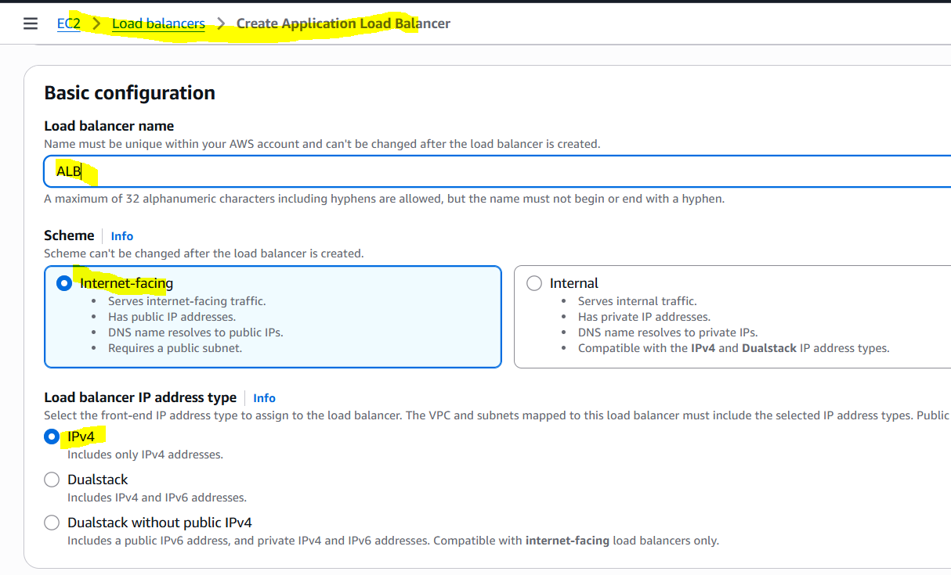

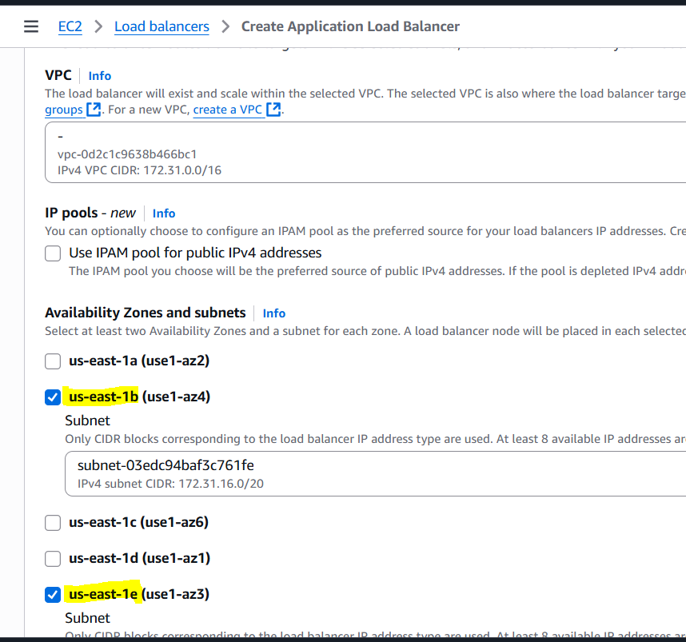

3. Configure security settings: Select the security groups.

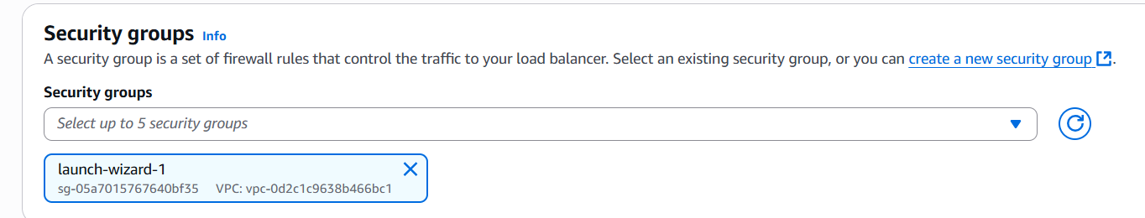

4. Configure listeners: Set the protocol (HTTP/HTTPS) and port.

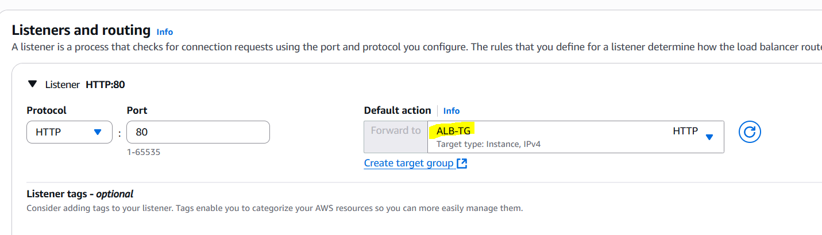

5. Configure target groups: Create a target group and select the target type (instance/IP).

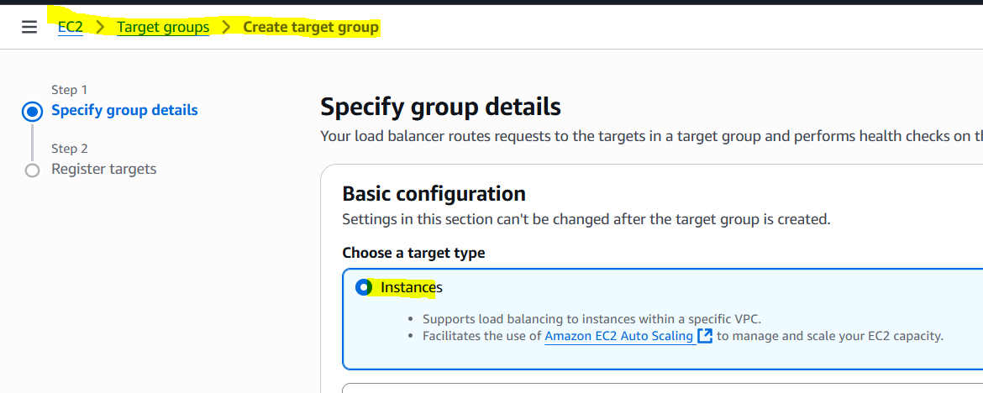

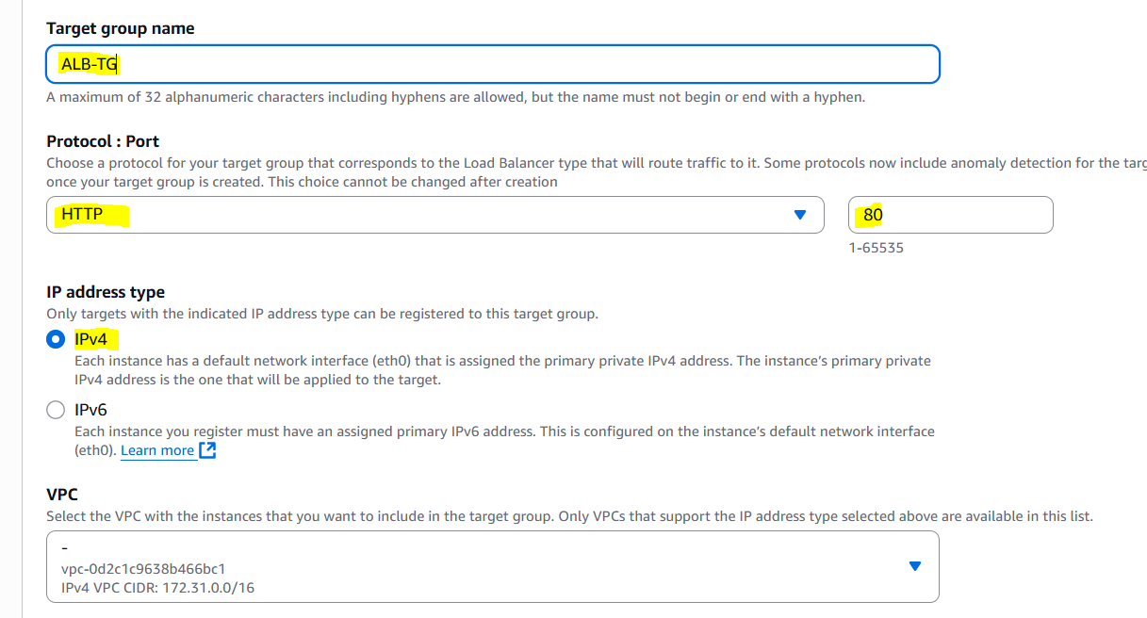

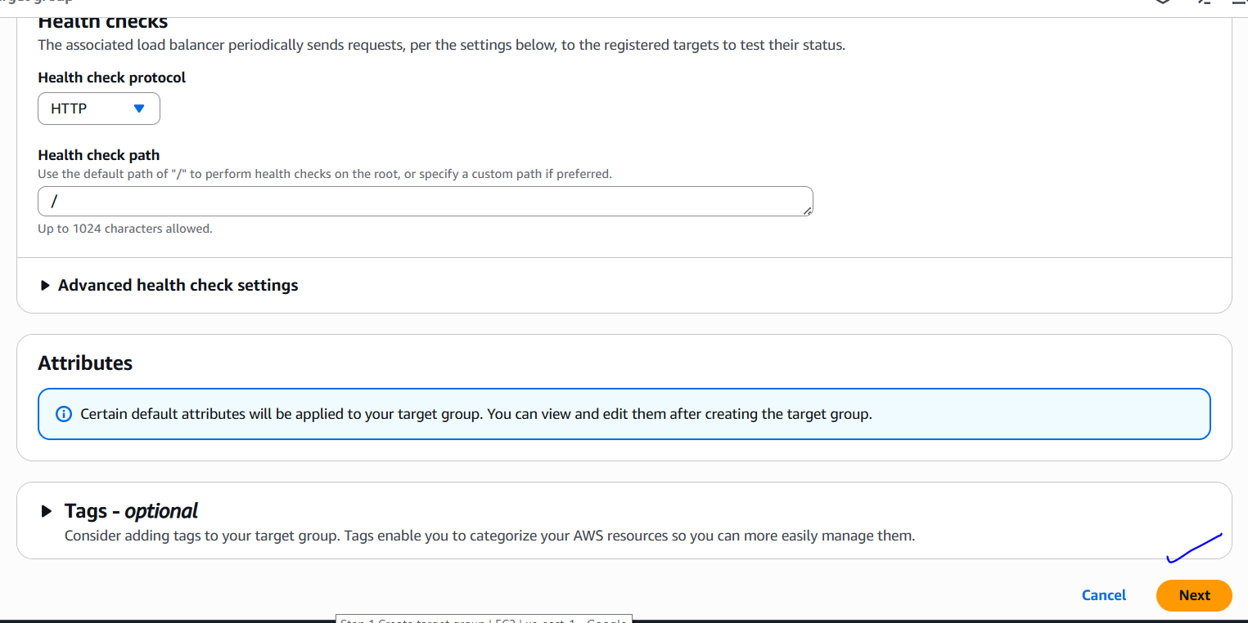

6. Add targets: Add the EC2 instances or IP addresses to the target group.

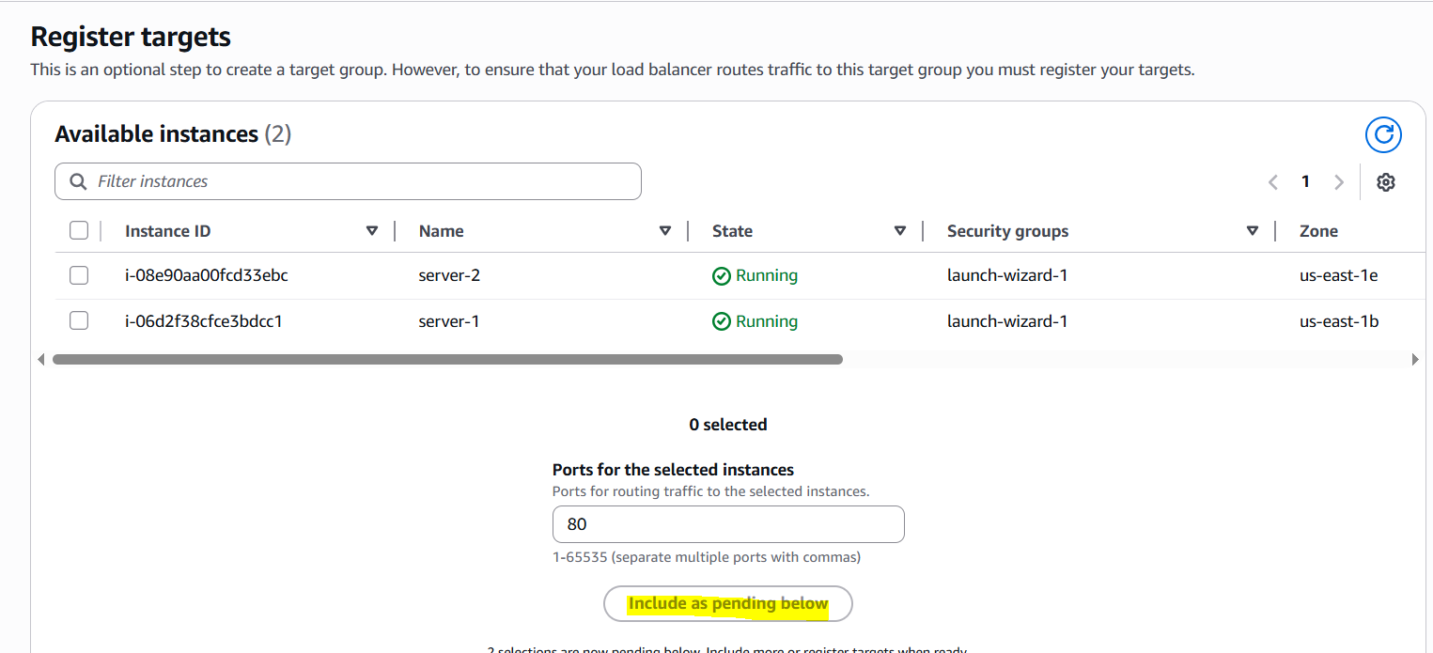

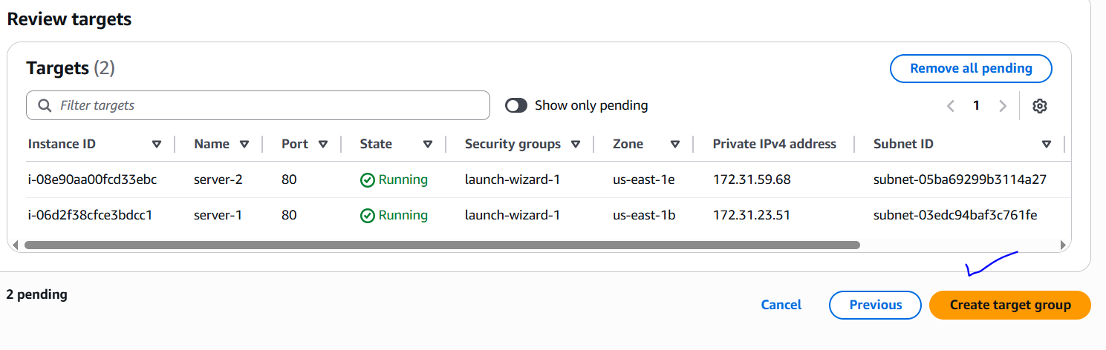

7. Configure routing: Configure routing rules based on URL paths or host headers.

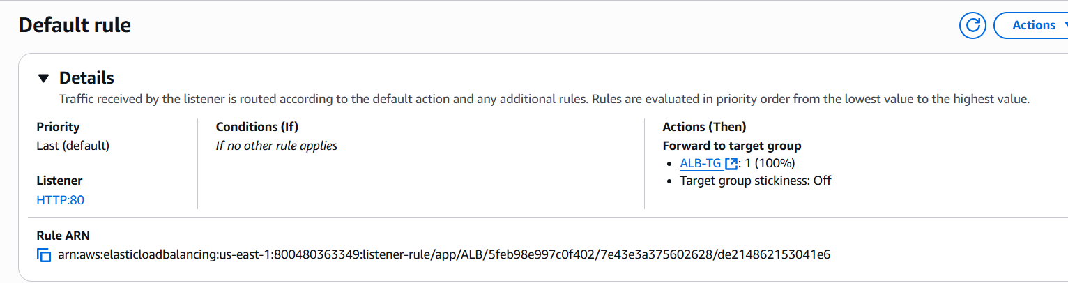

We got a default rule.

8. Review and create: Review the ALB settings and click "Create".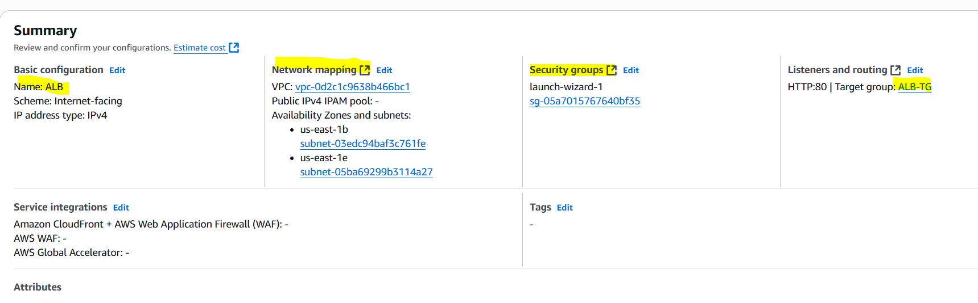

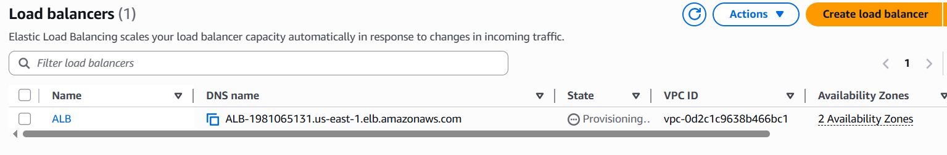

For testing copy DNS name and search in browser. For every refresh content may change as ALB distributes traffic to different targets.

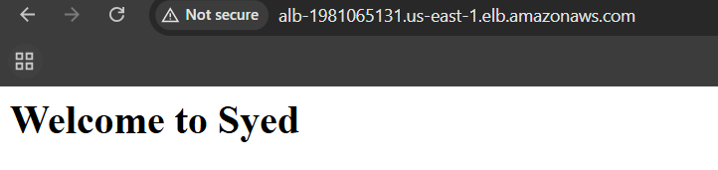

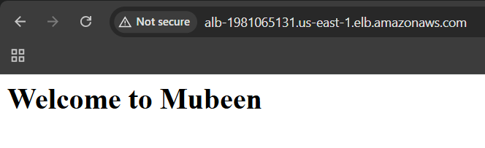

**3) Configure Network Load balancer.**1. Create a target group (specify protocol and port).

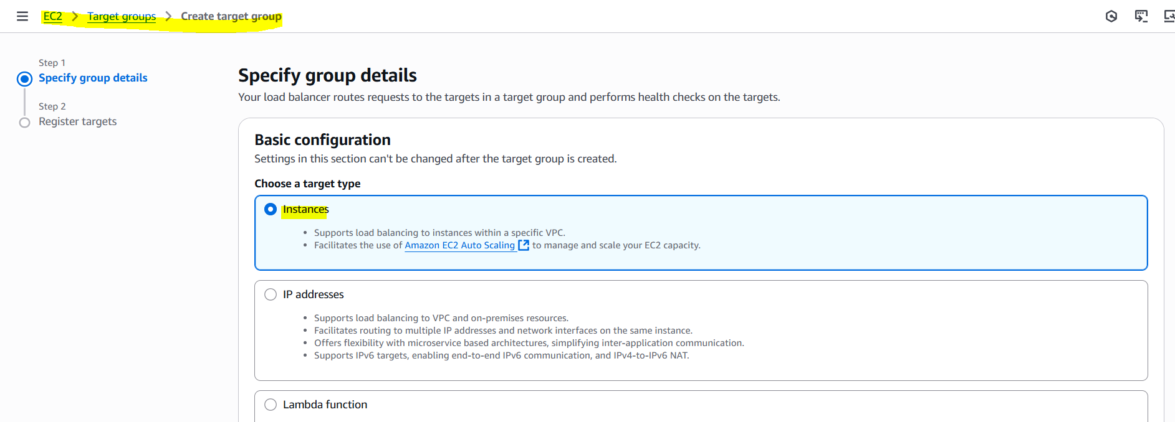

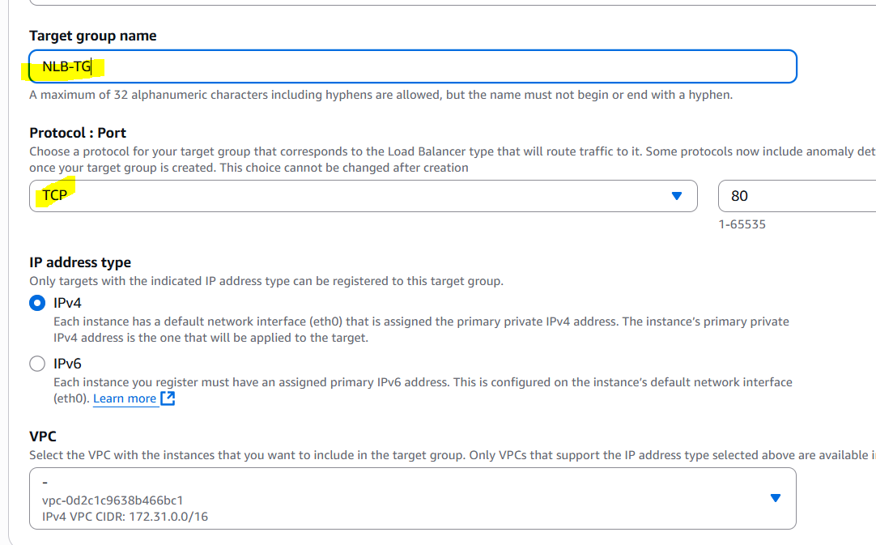

2. Register targets (EC2 instances or IP addresses).

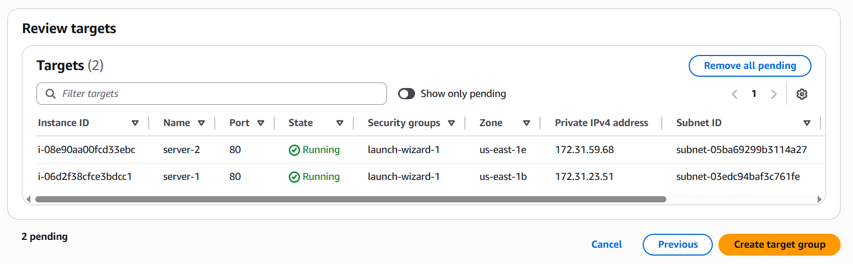

3. Create the NLB (specify VPC and subnets).

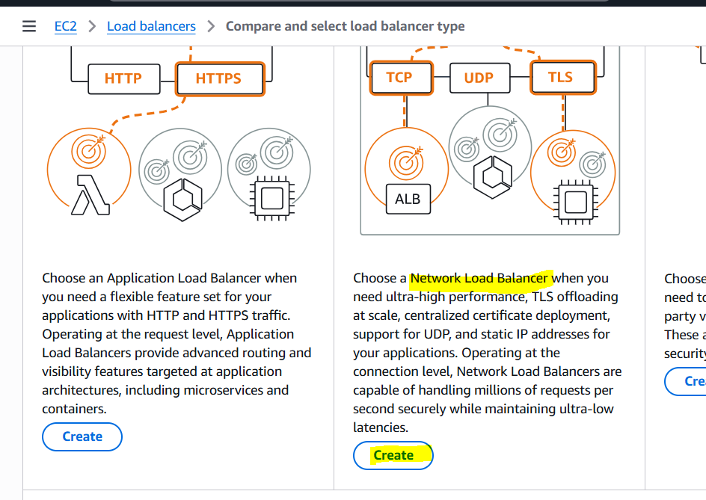

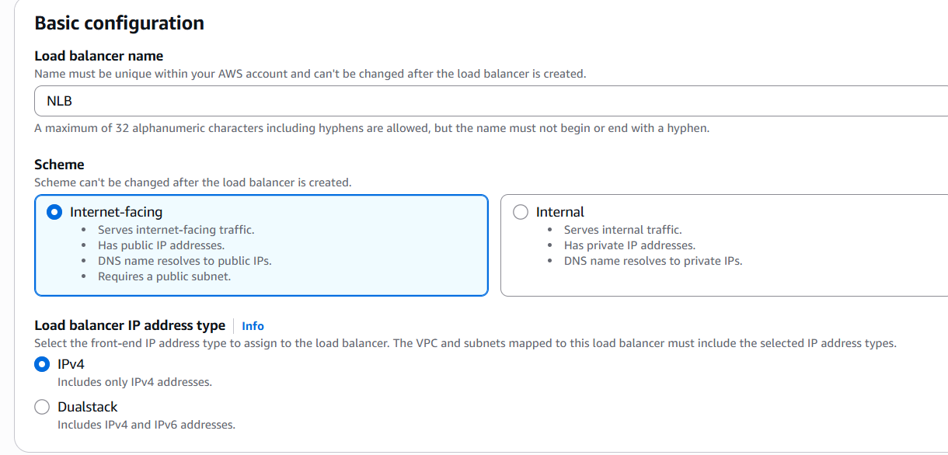

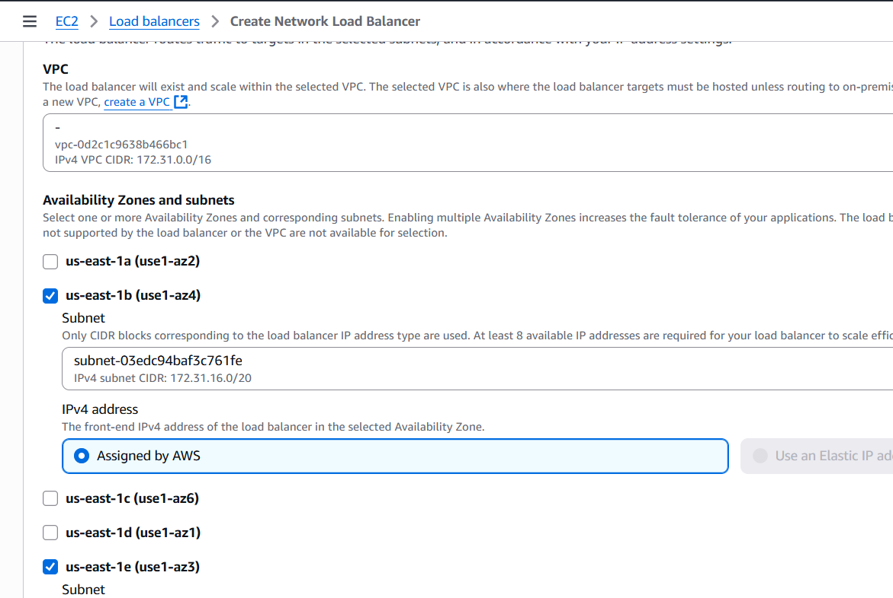

4. Configure listeners (specify protocol and port).

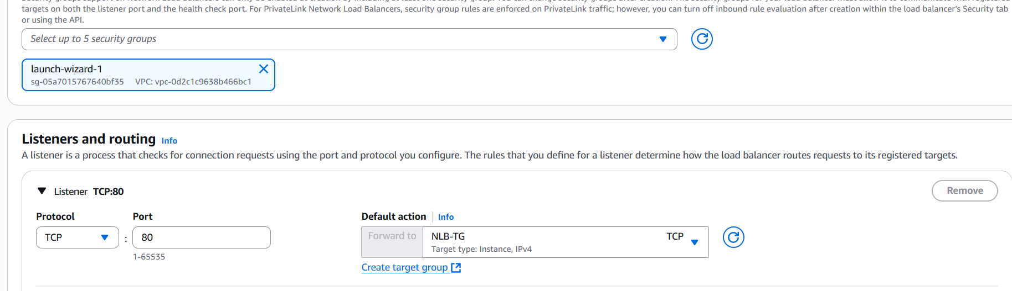

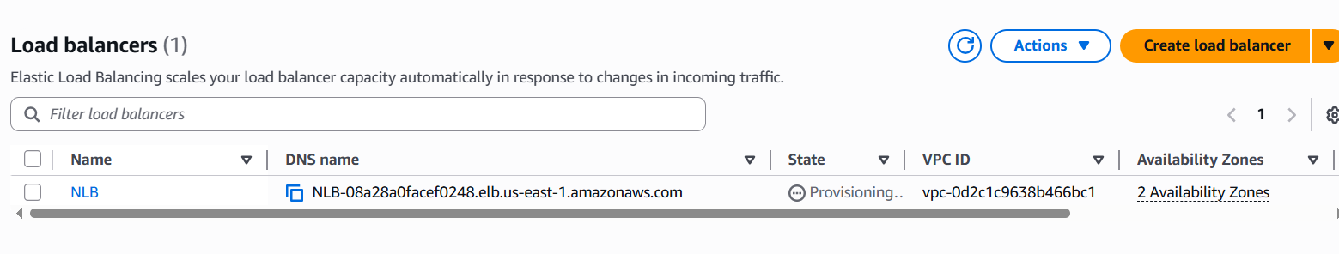

5. Associate the target group with the NLB.  
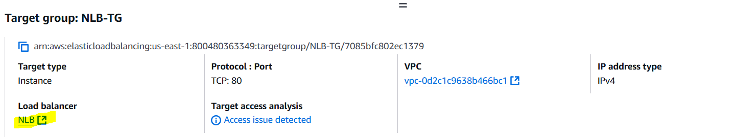

"NLB uses flow hash routing, which directs all traffic from a client to the same target, rather than true round-robin load balancing. The NLB will route to another server when the client IP or port changes."

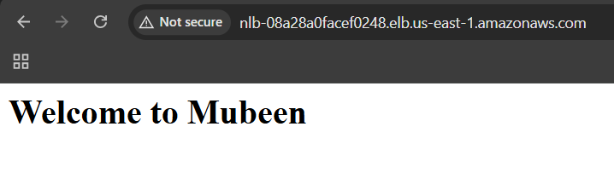

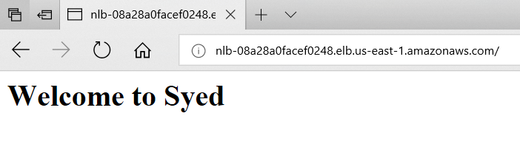

**4) Attach SSL for application load balancer.**1. We have an existing SSL for our domain.  
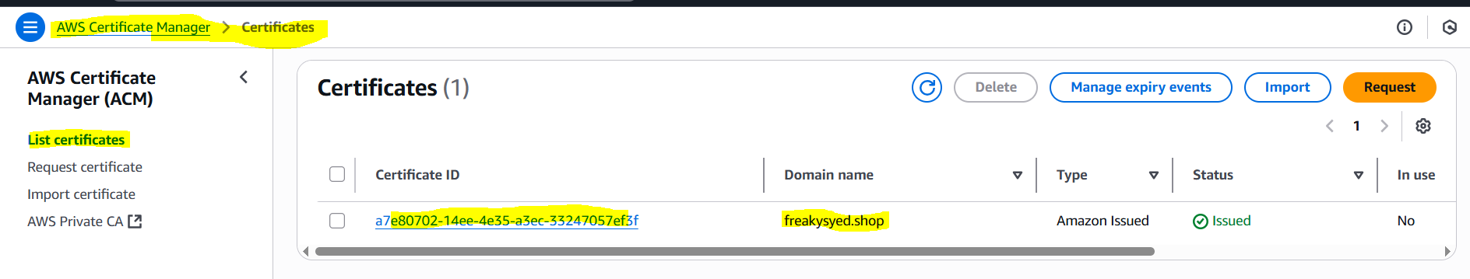

2. Go to the ALB settings: Navigate to the EC2 dashboard and select the ALB.

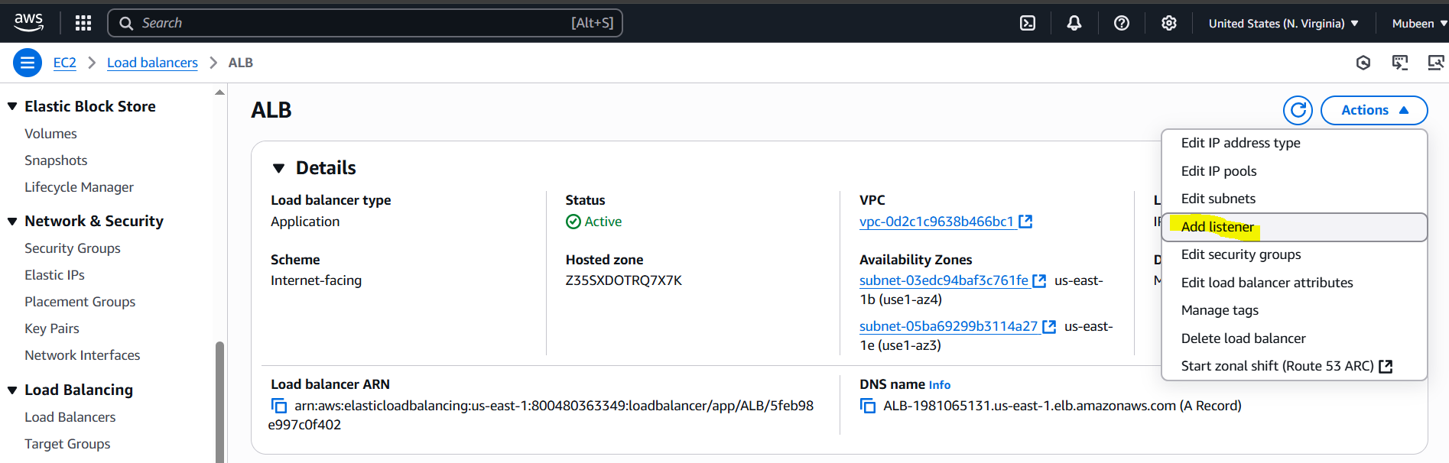

3. Edit the listener: Click on the "Listeners" tab and edit the HTTPS listener. (creating new one).

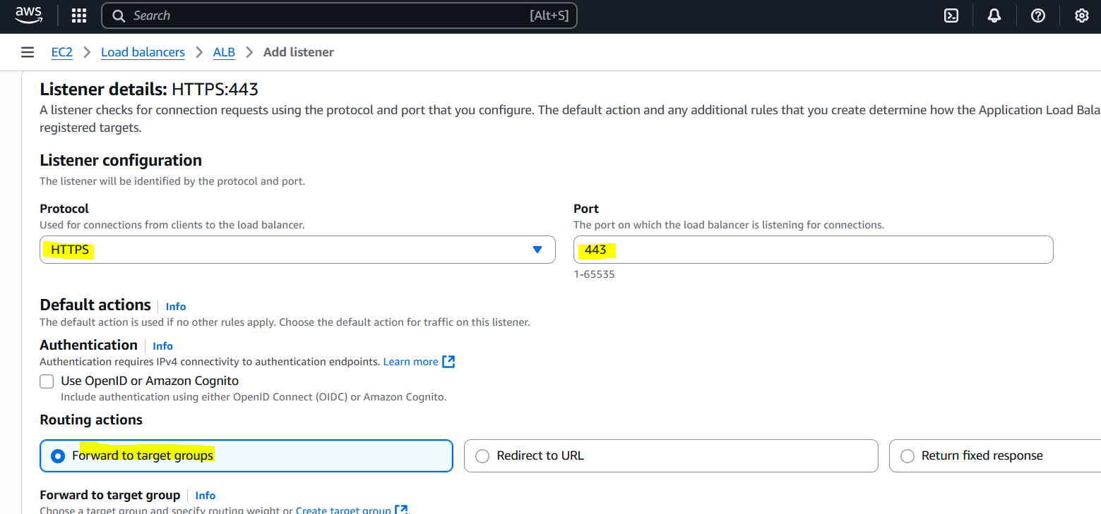

4. Select the SSL certificate: Choose the SSL certificate of step 1.

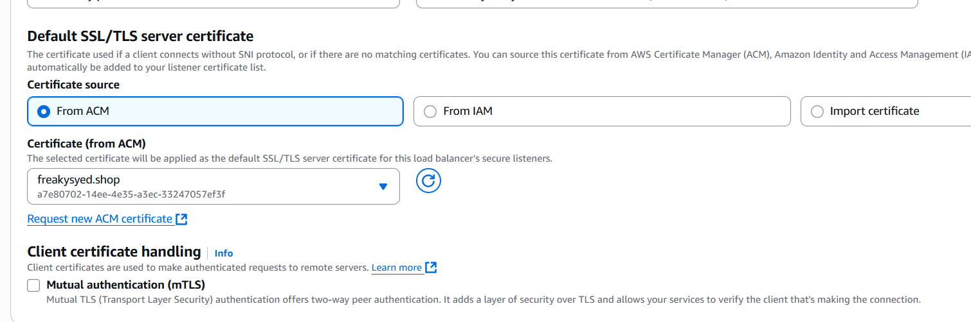

5. Save changes: Save the changes to the listener.

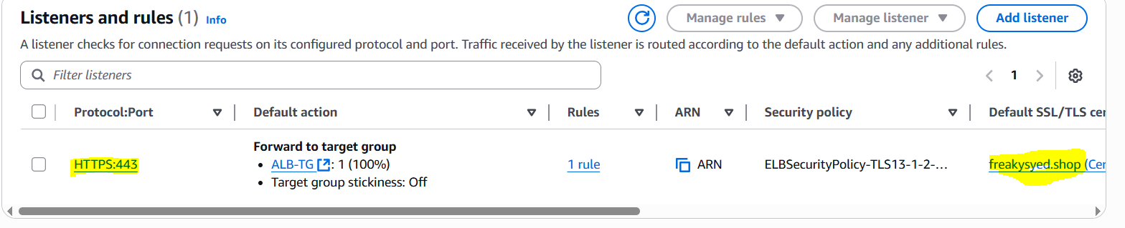

**5) Map Application load balancer to R53.**1. Create an R53 record set: Go to the R53 dashboard and create a new record set for your domain.

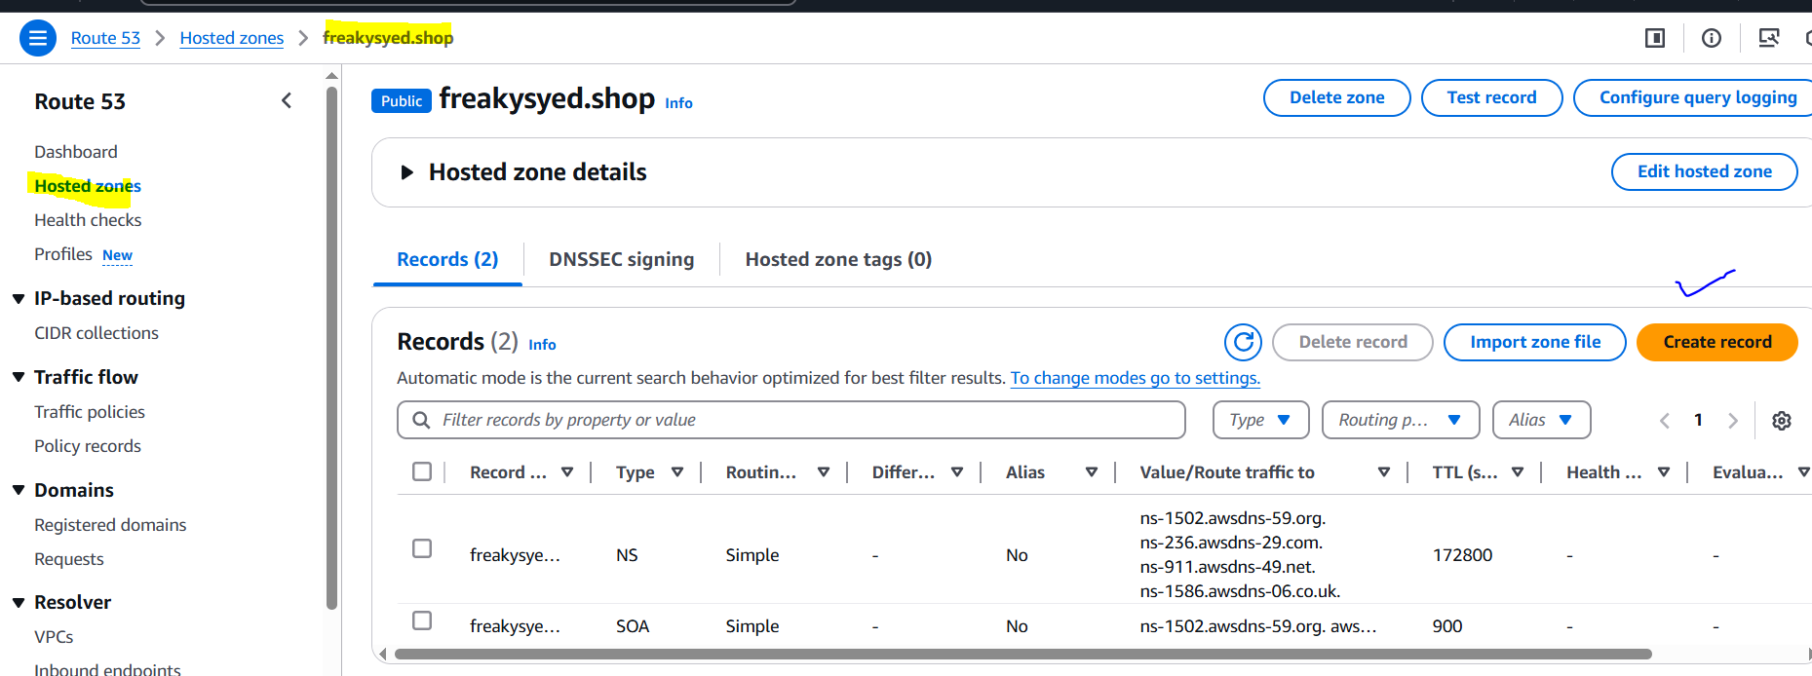

2. Choose the record type: Select "A - IPv4 address" or "Alias" record type.

3. Alias to ALB: Choose "Alias" and select the ALB's DNS name from the dropdown list.

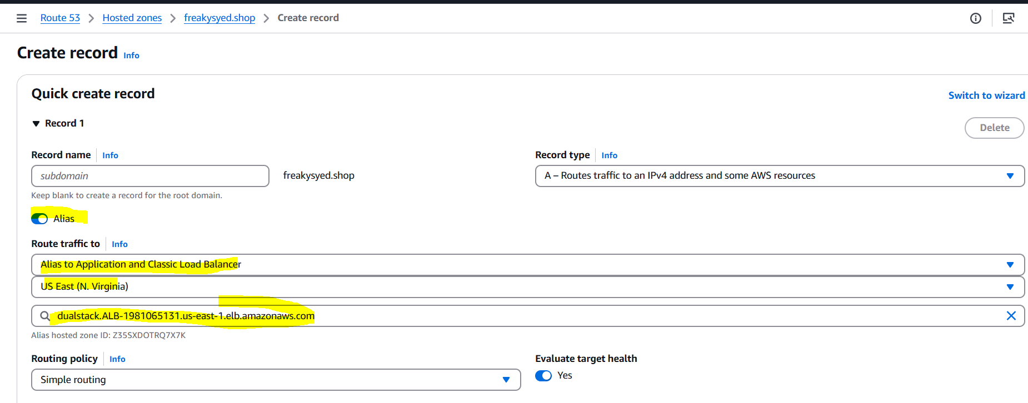

4. Save changes: Save the record set.

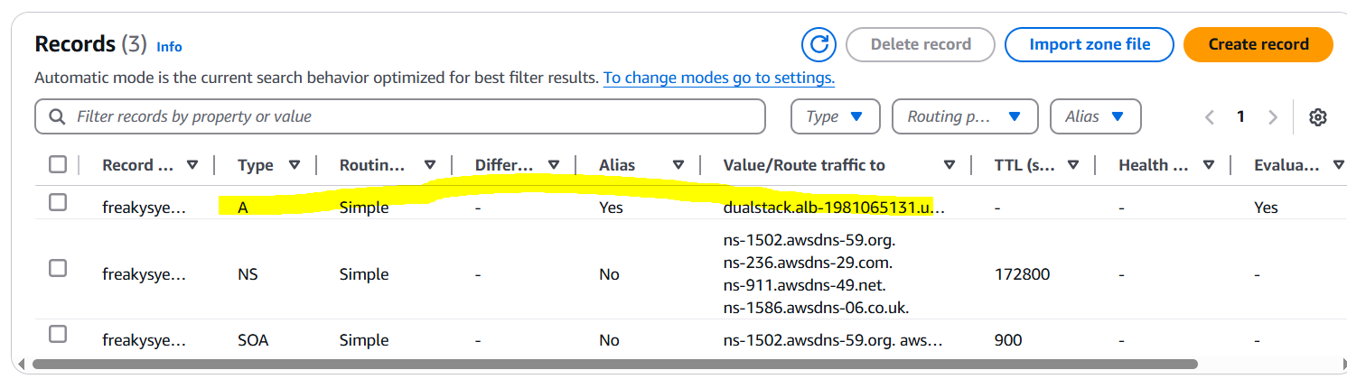

Verifying with DNS.  
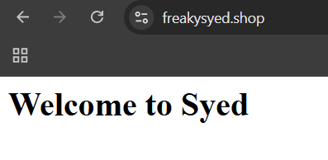  
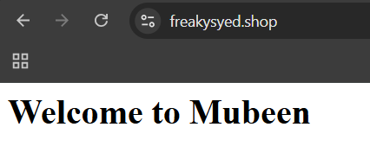

**6) Push the application load balancer logs to s3.**1. Go to the ALB dashboard: Navigate to the Load Balancers section.

2. Select the ALB: Choose the ALB you want to configure logging for.

3. Attributes: Click on "Attributes" and then "Edit attributes".

4. Access logs: Enable access logs and specify the S3 bucket.

5. Bucket permissions: Ensure the S3 bucket policy allows the ALB to write logs.

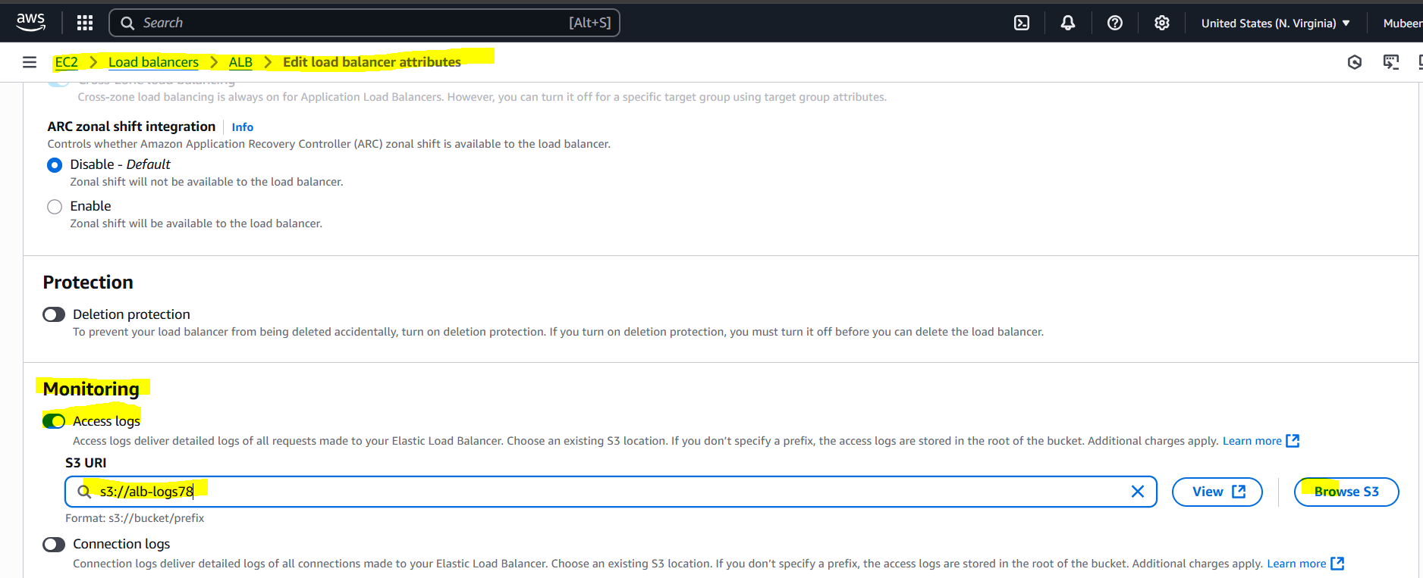

**Bucket Policy:**

1. Create a bucket policy: If you haven't already, create a bucket policy that allows the ALB to write logs.

2. Specify the ALB account ID: Use the ALB account ID for your region in the bucket policy.

{

"Version": "2012-10-17",

"Statement": [

{

"Sid": "AllowALBLogs",

"Effect": "Allow",

"Principal": {

"Service": "logdelivery.elasticloadbalancing.amazonaws.com"

},

"Action": "s3:PutObject",

"Resource": "arn:aws:s3:::alb-logs78/AWSLogs/800480363349/*",

"Condition": {

"StringEquals": {

"s3:x-amz-acl": "bucket-owner-full-control"

}

}

},

{

"Sid": "AllowALBLogsGetACL",

"Effect": "Allow",

"Principal": {

"Service": "logdelivery.elasticloadbalancing.amazonaws.com"

},

"Action": "s3:GetBucketAcl",

"Resource": "arn:aws:s3:::alb-logs78"

}

]

}

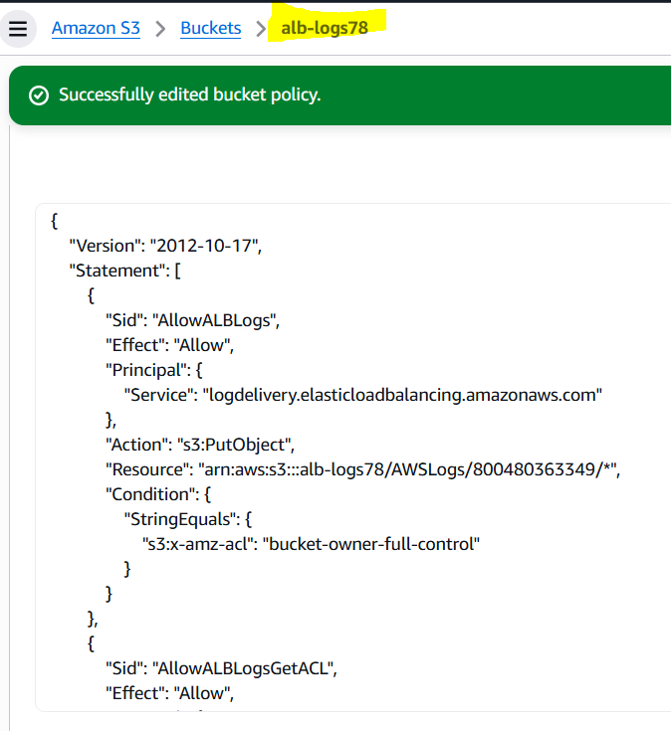

**Verify:**

1. Check S3 bucket: Verify logs are being written to the S3 bucket.  
   2. Log format: Ensure logs are in the expected format.  
     
   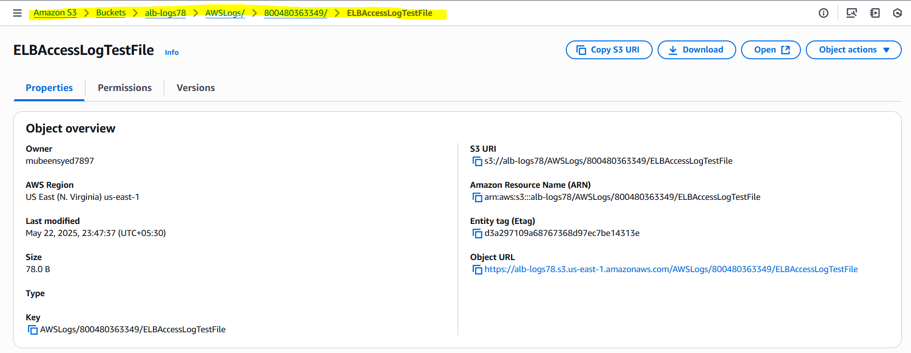

**The-End**